**ERD DIAGRAM:**

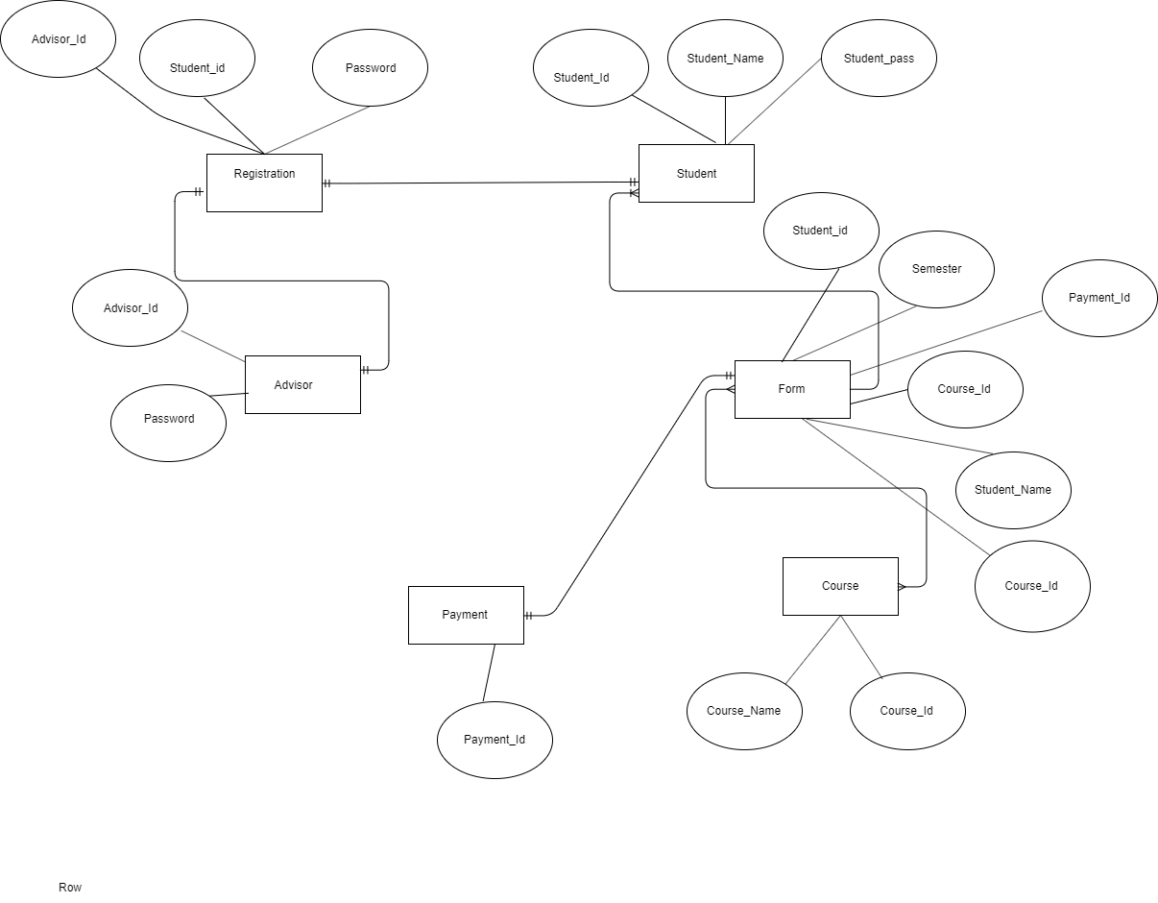

**ERD DIAGRAM (Table):**

